## DAP

For the DAP’s (see Figure 8‑7) it is practically the same as for the workstation. The only difference is that you will have to set the station selection of a DAP on a server under Alarm Stations/Alarm Panels (see Figure 8‑8). For the rest it will be the same as the alarm screen of a workstation and it will depend on the Matrix that we discuss later.

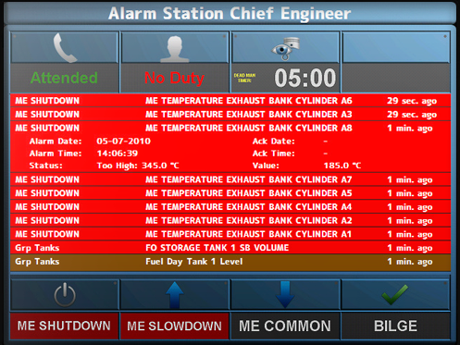

Figure 8‑7: DAP screen

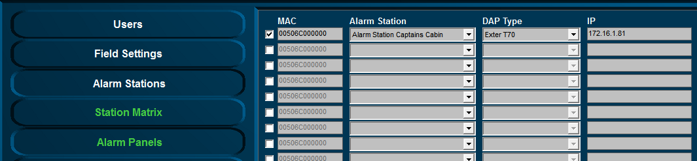

Figure 8‑8: DAP configuration